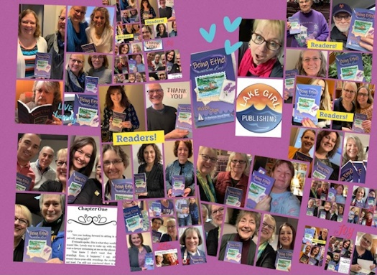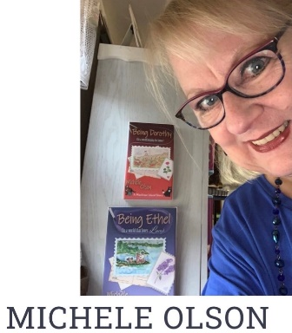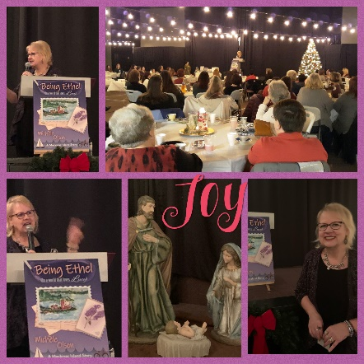
Michele is a seasoned writer, broadcaster, voice pro, speaker, artist, and author with over 40 years of experience. With over 100 blog articles as a health writer, and the voice for countless commercials, videos, and voice-over projects, her focus is author and speaker based on Mackinac Island stories filled with mystery, romance, friendship, and faith.
The author of Being Ethel (In a world that loves Lucy) and Being Dorothy (In a world longing for home) and Being Alice (In a world lost in the looking glass) she writes to Fuel Faith with Fiction™ as the main goal of her creative imprint-Lake Girl Publishing and LakeGirlPublishing.com.
Her message involves the common experience of being overlooked and playing the role of “Ethel” when the world treasures “Lucy.” She shares the truth of being seen, valued, unique, and important for every person.
Being Ethel (In a world that loves Lucy) is a 5-star reviewed novel in eBook, paperback, and audiobook which has hit the top 100 on Amazon.
Along with her debut novel, her stand-alone sequel- Being Dorothy (In a world longing for home) is another 5-star reviewed novel being well-received in bookstores, libraries, and book clubs in eBook and paperback.
The third book in the Mackinac Island story series – Being Alice (In a world lost in the looking glass) is receiving 5-star reviews and is a top seller on Mackinac Island. A wife, mother to two adult children, a mother-in-love, and Gee Gee to two grandchildren, Michele enjoys connecting with readers in-person and through social media.
An interview with Michele on Writer CEO blog: Life Lessons from Forty-Five Years in the Writing Trenches! | WriterCEO.com A podcast interview with Michele by Sarah Hamaker on the Romantic Side of Suspense, the Beauty of Mackinac Island: https://lnns.co/BZntJpHgONE
and another interview at https://lindarondeau.com/snarksensibility/508-BEING-ETHEL-IN-A-WORLD-THAT-LOVES-LUCY?sel=1-1 examples of background and interviews.
For interviews, speaking events, book signings, or comment, contact Michele at:
info@lakegirlpublishing.com www.lakegirlpublishing.com
Visit her website to learn more about her books, hear her voice over work, art, audiobook examples and more!

